ALGWA NT Branch Inc
Branch Report to ALGWA National AGM 2017
ALGWA NT is currently experiencing a bit of a lull. Our membership is very low and the committee is now working towards a strategy of encouraging more members. This is complicated by the fact that we are currently in a local government election year.
This year we have undertaken the following activities:
- Annual Networking Seminar – This year the Annual Networking seminar had Carmel Noon, State Manager for the Australian Institute of Company Directors S/NT Branch as keynote speaker. Carmel entertained an audience of 30 with stories of her time as CEO of Kangaroo Island Council, as well as current governance issues. One lucky member won a free course with AICD.
- IWD March – The IWD March was led by the ALGWANT members. Over 600 people attended the march which was a partnership with the City of Darwin, Office of Womens Policy (NT Gov) and the United Nations Association.
- LGPro MOU – Following on from the successful negotiation and signing of an MOU with LGANT (Local Government Association of the NT); we have now signed one with LGPro NT Branch. Our relationships with both these key local government organisations has enabled us to extend the range of our messaging as we access their memberships as well.
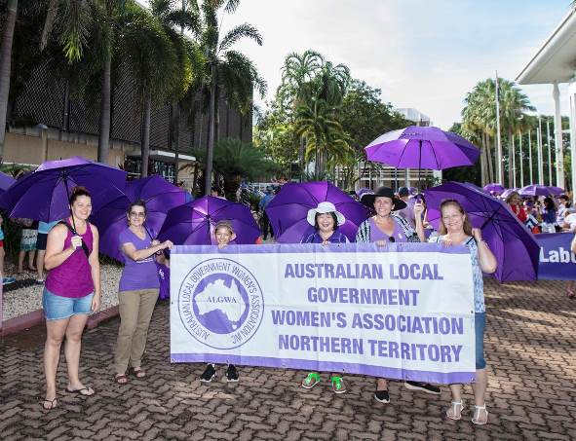 | 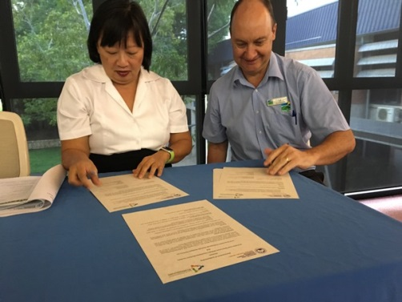
IWD March LG Pro NT Branch President Ricki Bruyn signing MOU

Katrina Fong Lim
ALGWA NT Branch President

