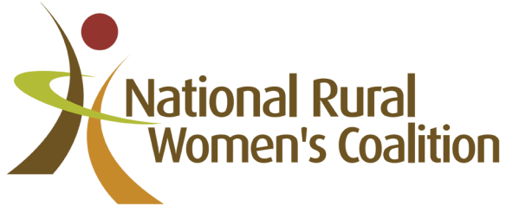

National Rural Women’s Coalition Report 2017
It was a huge honour to be elected as President of the NRWC in November 2016 and my training and experience as an elected member in local government has stood me in good stead for this new role.
I enjoy the challenge of making ideas happen, or achieving outcomes that are worthwhile to communities, but I look to others for their knowledge and experience so that team work may produce a better delivery of goals and objectives. As a strong advocate for women, I am always willing to act as a mentor because I enjoy watching the growth and development of another person but in the end it becomes an amazing sharing process. I also believe the Simon Sinek quote, “If a movement is to have an impact it must belong to those who join it, not to those who lead it.” So for this reason, one of my goals is to work much more closely with our Member Organisations particularly in the areas that concern them.
Last year we completed 22 Projects that impacted on more than 250,000 women across rural, regional and remote Australia, helping them to create change in their lives and their communities. It is pleasing to see that one of our earlier e-Leader graduates has gained the NSW RIRDC Award with a project she began as part of the popular e-Leader course. We have produced a sensitive story book that addresses family violence issues aimed at 4 – 8 year old children. It comes with a set of downloadable work sheets that prompt discussion for parents and teachers or provides some creative reinforcement activities for children.
We employ three part time contractors who manage our administration, finance and social media communications. Our eight Directors represent our member organisations, with three being independent members. We each put in a large number of hours in a year, estimated at over $147,000. I seek to involve our ALGWA proxy member more so that some succession benefit is achieved.
ALGWA membership is a great stepping stone to the very influential National Rural Women’s Coalition.
Alwyn Friedersdorff

