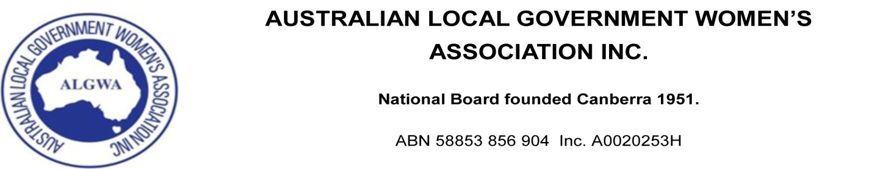
MINUTES OF ANNUAL GENERAL MEETING HELD AT THE CENTRE IVANHOE ON 7th APRIL 2016.
1. President Coral Ross welcomed all delegates.
2. Confirmation of Delegates
New South Wales: Vicki Scott
Qld: Rebecca Hersant
South Australia: Betty Gill
Tasmania: Alwyn Friedersdorff
Victoria: Coral Ross
Western Australia: Janet Davidson OAM
In attendance: Helen Harris OAM

3. Apologies and acceptance of proxies
N.T. Katrina Fong Lim; no proxy appointed

4. Confirmation of previous AGM Minutes of 27 March 2015. The previous minutes were moved Helen Harris, seconded Coral Ross and carried.
5. Business Arising from the Minutes: Nil

6. President’s Report. The President spoke to her report, which had been previously circulated. It was moved Coral Ross, Betty Gill seconded, that the Report be accepted. Carried.
7. Financial Reports. The Treasurer spoke to her report, which had been previously circulated. It was moved Alwyn Friedersdorff, seconded Coral Ross, that the Report be accepted. Carried.
8. Appointment of Auditor.
It was moved Alwyn Friedersdorff, seconded Janet Davidson, that Thomas Simpson Partners of Newcastle NSW be re-appointed. Carried.
10. Setting of Annual Affiliation Fees. It was moved Alwyn Friedersdorff seconded Rebecca Hersant that the percentage of annual affiliation fees remain the same. Carried.
11. Setting of Honorariums. It was moved Betty Gill, seconded Janet Davidson, that the President’s honorarium be increased to $2,000, and the secretary and treasurer honorarium remain at $1,000 each. Carried.
12. State Branch Reports. Having been previously circulated, it was moved Janet Davidson, seconded Rebecca Hersant, that the Reports be accepted. Carried.
13. Proposed alteration to Constitution. A Discussion Paper having been previously circulated, the following Special Resolution was moved Betty Gill, seconded Helen Harris and carried.
“That Clauses 16.1 and 16.2 relating to Notice of the Annual General Meeting be deleted and replaced with a new Clause 16.1:
The Secretary shall, not less than thirty days before the Annual General Meeting, cause to be sent to each Branch a notice stating the date, time and place of the meeting, and calling for any items to be included on the agenda for such meeting, to be forwarded to the Secretary not less than ten days prior to the date of the meeting.”
14. General Business for which previous notice has been given. Nil.
15. The next Annual General Meeting will be held at Launceston Tasmania on 12th April 2017.

